# 3 E - Synthesis of Ethanol

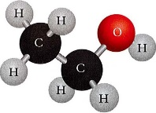Ethanol (C2H5OH) is the most well-known of the chemical group of alcohols, and it can be produced by several methods.

The most common method is a chemical one – an addition reaction between ethene and water. This process is also known as catalytic hydration, or hydrolysis. This method is used to produce most industrial quantities of ethanol.

However the commonly known method is a biological process – the fermentation of sugars by yeast. This method is used to produce alcoholic drinks, although the ethanol can also be separated out and used for industrial purposes.

## Ethanol fermentation

Producing ethanol by fermentation essentially involves the metabolising of glucose like monosaccharides by yeast under anaerobic (no available oxygen) conditions. The yeast use the glucose as a source of energy, and without oxygen available, the yeast respire anaerobically, and therefore produce less carbon dioxide and more alcohol as a product.

There are several monosaccharides which can undergo fermentation, including glucose, mannose, galactose, and fructose. For example, glucose undergoes fermentation form ethanol and carbon dioxide. The chemical reaction is:

*Zymase*



C6H12O6(aq) 2 C2H5OH(aq) + 2 CO2(g)

Within the yeast the fermentation reaction is actually catalysed by the enzyme *Zymase*. In addition the yeast contain the enzyme *invertase*, which catalyses the breakdown of sucrose disaccharide into fructose and glucose, which can both undergo fermentation.

Generally, the plant biomass used for the fermentation process high in simple sugars like sucrose, glucose and fructose. However other biological enzymes can convert large polysaccharides to simple monosaccharides. The use of these enzymes on plant biomass which has high concentrations of polysaccharides can increase the concentration of simple sugars. Thus enzymes can be used to prepare plant biomass which would otherwise be considered unsuitable for fermentation. For example *amylase* can convert starch to maltose, and *maltase* can convert the maltose into two glucose monomers which can then undergo fermentation. This application of enzymes is relatively new, but may increase the availability of plant sources for use as biomass.

This fermentation process stops once the ethanol concentration reaches approximately 13 to 15% because yeast will not function at higher concentrations of alcohol. To produce higher concentrations of ethanol, distillation is used to concentrate the ethanol.

### Hydration of Ethene

Most ethanol is produced by the direct hydration of ethene, under conditions of relatively high temperature and pressure; 300°C and 70 atm. Concentrated acid acts as the catalyst.

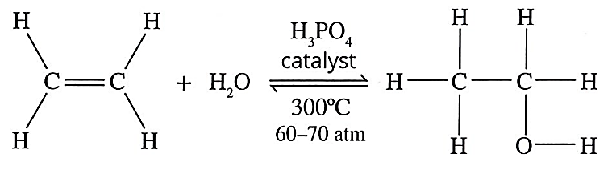

Acid